**PHY 101 Assignment 1 Spring 2021**

**Name: Abdul Rehman**

**VU ID: BC200403287**

**Assignment: Phy101**

**Question # 1**

The student of Physics claims that he has calculated a negative potential difference between two points. Is it true or wrong? Either yes or no explain it by giving a suitable example. Marks = 5

**Solution:**

Conceptually the answer is Yes, if a student calculate difference between the higher point A with others lower point B, then the potential difference is definitely negative.

**Reason:**

In conservative field (gravitational field and electrostatic field) the potential is a function only of position. This response applies to motion in such fields where the only energy involved is exchange between work and potential energy. It is incomplete to state that the potential difference between two points. We must specify the potential of one with respect to the other point.

Thus, there is nothing conceptually wrong with a negative potential difference between two points.

**Example:**

Suppose we have two points A and B. The value of A is 12V and value of B is 10V.

A - B = 12V – 10V = 2V.

B - A = 10V – 12V = -2V.

**Conclusion:**

It is **true** that we can calculate a negative potential difference between two points.

**Question # 2**

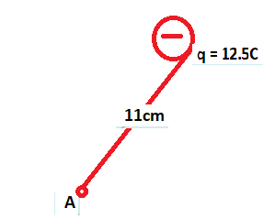

Determine the magnitude as well as direction of the electric field at point A, shown in the above figure. Given the value of k = 8.99 × 1012N/C. Marks = 10

**Solution:**

**Given** in the question:

**k** is the Coulomb constant is 8.99 **×** 1012 N/C.

**q** is the charge = 12.5C.

**r** is the distance from point A to q = 11cm = 0.11m.

**E** =?

**Finding Magnitude and Direction of E:**

Formula of E:

.

Simplify:

.

.

Putting the values in Formula:

.

**E = 9.2 × 1012 N.**

**Explanation of direction:**

So, the direction of ‘E’ depends on the nature of test charge (+ve or -ive). In negative test charge E is opposite to F and position is same as F.

**Question # 3**

In the figure shown, the lamp cord is 85cm long and comprises cupper wire. Calculate the wire‘s resistance? Use value of resistivity for Cu as 1.75 × 10-8Ωm. Marks = 10

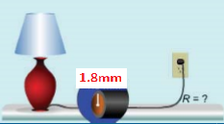

**Solution:**

**Given:**

Length **L** = 85cm = 0.85m

Resistivity for Cu **P** = 1.75 × 10-8 

Radius **r** = 1.8mm = 0.0018m

**To find:**

Resistance **R**=?

Formula: R = 

R = 

Now by putting values we have:

R = 



**R = 1.4 × 10-3**